INSPECTION FORM REMOVABLE CONCRETE ANCHORS
FOR MORE RESOURCES and DOWNLOADS:
visit our website: https://hsseworld.com.com

Serial #
Date of First Use: Date of Manufacture:
Owner/Company:
Inspector:
Date of Inspection:

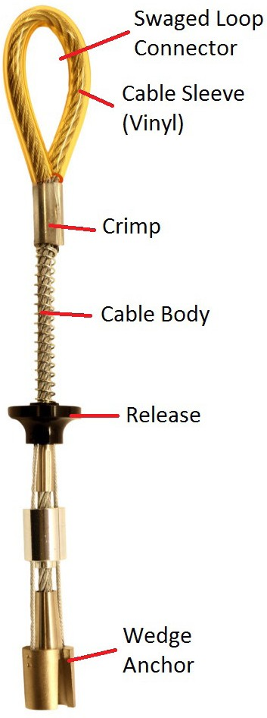
Pass Fail
LABELS & MARKINGS

Correct Part Number labeling?
Correct Batch Number labeling?
Are inspections are current/up-to-date?
Is date of first use documented?

Pass Fail
CONNECTORS

Does spring function smoothly?
Does wedge anchor move freely?
Is connector free of corrosion?
Is connector free of pitting & nicks?

Notes:

