Safety Form
CHEMICAL RISK ASSESSMENT
Location: |  | Department/Group/Section:
INFORMATION ON HAZARDOUS CHEMICAL REFERRING TO SAFETY GUIDELINE
Hazardous chemical/substance: |  | Trade name:
Description of the activity:
Is the chemical? (Check for a pictogram in section 2 of the safety data sheet).
Explosive substance | CMR¹ | 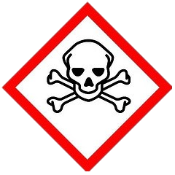  Acute toxicity |  |  |  | 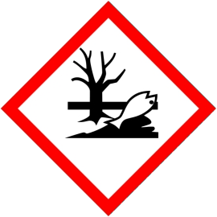  Hazardous to the aquatic environment
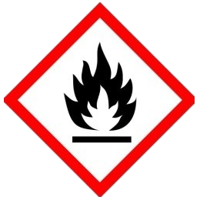  Flammable substance | Specific Target Organ Toxicity (STOT) | 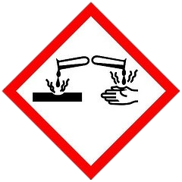  Corrosive |  |  |  | Other
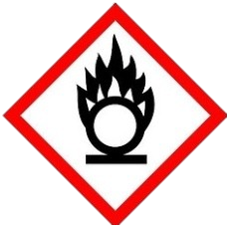  Oxidizing substance | Respiratory sensitizer | Irritant/Skin sensitizer
Can a non/less hazardous chemical be used for this activity? If ‘yes’ give reasons for not using: |  |  | Yes |  | No
CHEMICAL RISK ASSESSMENT (INHALATION) REFERRING TO SAFETY GUIDELINE
To which Hazard Band is the chemical assigned? A |  | B | C |  | D | E
How volatile is the chemical? Low Medium |  | High
What amount of the chemical is used? Small Medium |  |  |  | Large
What is the calculated risk level? 1 2 3 |  | 4
How often and for how long is the chemical used? (Per day, week, month)
Who is exposed to the chemical? (Indicate names)
CERN Staff CERN Users Public Students Contractors Others

PREVENTION AND PROTECTION MEASURES REFERRING TO GSI-C-1
What control measures are required for this chemical, other than Personal Protective Equipment (PPE)?
General ventilation  Glove box (indicate ID No. of item)  Fume cupboard (indicate ID No. of item)  Capturing hood (or other LEV²) (indicate ID No. of item) |  |  |  |  |  |  |  |  | Work instructions or procedures (Give ref.)  Other (state type required)
Is any Personal Protective Equipment (PPE) required when using the chemical?
 |  |  |  |  | Eye protection |  |  |  | Mask/respirator (give ref.)
 |  |  |  |  | Eye and Face protection |  |  |  | Gloves (give ref.)
 |  |  |  |  | Overalls/clothing |  |  |  | Other (give ref.)
Description of exposure monitoring: (describe proposed exposure monitoring for chemicals, and give results in relation to any occupational exposure limits for the chemicals concerned)
Storage requirements?
Spill retention Local exhaust ventilation |  |  |  |  |  |  | Access control/locked cupboard |  |  |  |  | Incompatible materials/ chemicals (give details)
How have workers been provided with information or training? (Give details)
Training course Individual instruction supported by written information
OTHER PRECAUTIONS & EMERGENCY PROCEDURES
Safety shower/eye wash |  |  |  |  |  | First-aid (give details) |  | Absorbent materials (specify) |  |  |  |  | Fire protection measures  (give details)
EVALUATION & ACTIONS
Are all the controls detailed above currently in place? |  |  |  |  |  |  |  |  |  |  |  |  |  | Yes |  |  |  |  |  |  |  |  |  |  | No
If these controls are not in place or additional controls are required, state action to be taken.
Please note – hazardous chemical agents must NOT be used if adequate control measures are not in place.
Remedial actions required |  |  |  |  |  |  |  |  |  |  | Date for completion |  |  | Assigned to
dd/mm/yyyy dd/mm/yyyy dd/mm/yyyy
dd/mm/yyyy

TRACEABILITY
Reference No.: |  |  | EDMS No.:
The assessor signs to certify that hazards to health are adequately controlled with all control measures in place.
Assessor(s) name: | Assessor(s) signature: | Date: dd/mm/yyyy
Assessor(s) name: | Assessor(s) signature: | Remedial actions complete:  dd/mm/yyyy
Assessor(s) name: | Assessor(s) signature: | Reviewed on³:  No change  Changes (give ref. or ver. No. of new assessment)
The HSE Unit shall authorize the start of activities having major Safety implications.
HSE Unit (name): | HSE Unit signature: | Date: dd/mm/yyy
Distribution list: (Organic Unit, HSE Unit, DSO, TSO)

A copy of the safety data sheet(s) concerned by this assessment must be available for consultation. A copy of this assessment shall be kept in a known and readily accessible location.

