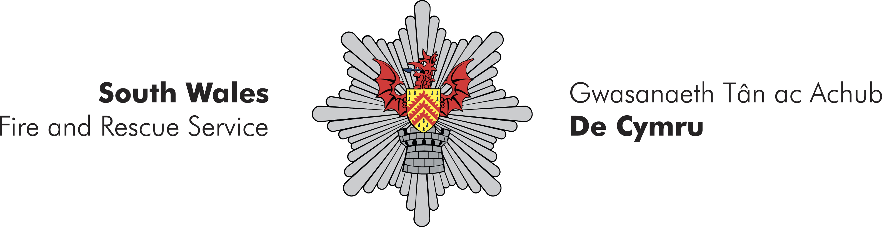
Raising Awareness – Reducing Risk

CHANGE THIS TITLE TO COMPANY NAME

This Log book should be kept up to date and be made
available for inspection by the Fire Authority

Property / Business Name
Address Line 1
Address Line 2
Town
Post Code
Contact Name 1
Contact Name 2
Contents

1. Useful Contacts Page 3

2. The Regulatory Reform (Fire Safety) Order 2005 Page 4

3. General Fire Safety Requirements Page 6

4. Fire Alarm System Page 8

5. Unwanted Fire Signals Page 10

6. Emergency Lighting System Page 12

7. Fire Fighting Equipment Page 14

8. Sprinkler Systems Page 16

9. Smoke Ventilation Systems Page 18

10. Miscellaneous Provisions Page 19

11. Fire Instruction and Training Page 21

12. Fire Evacuation and Drills Page 23

13. Fire Risk Assessment Page 25

14. Business Continuity and Planning Page 26

1. Useful Telephone Contacts

Contact | Company | Number
Fire Alarm Service Engineer
Fire Extinguisher Engineer
Emergency Lighting Engineer

For further fire safety advice please contact:

ADVICE LINE: 01443 232500

E-Mail:
firesafety@southwales-fire.gov.uk

Information about Fire Protection or other related matters can be found on the South Wales Fire & Rescue Service Website:

www.southwales-fire.gov.uk

and at:
www.fire.gov.uk

Information and guidance is available in the fire safety guides published by Communities and Local Government:

www.communities.gov.uk
2. The Regulatory Reform (Fire Safety) Order 2005

The vast majority of sites and premises throughout England & Wales must now conform with the requirements of the Regulatory Reform (Fire Safety) Order, which has replaced the Fire Precautions Act 1971 and the Fire Precautions (Workplace) Regulations 1997, as well as over 100 pieces of legislation relating to Fire Safety.

The Fire Safety Order does not apply to people’s private homes, including individual flats in a block or house, though it does apply to; common areas; shared means of escape and facilities provided to assist the Fire Service, such as dry risers.

This fire safety logbook has been prepared to assist building owners, managers and other responsible persons to co-ordinate and maintain a fire safety record keeping system.

The logbook is also seeks to cover the main requirements for demonstrating compliance with current fire safety legislation. It is recommended that it be kept in a loose leaf format with new record keeping pages photocopied or downloaded when required. The logbook should be kept up to date and readily accessible for inspection by the enforcing authority when required.

In terms of maintaining records it is important to take note of the following legal requirements;

Article 32 (2) (b) Regulatory Reform (Fire Safety) Order 2005

‘It is an offence to make in any register, book, notice or other document required to be kept, served or given by or under, this Order, an entry which he knows to be false in a material particular.’

Article 17.1 Regulatory Reform (Fire Safety) Order 2005

‘Where necessary in order to safeguard the safety of relevant persons the responsible person must ensure that the premises and any facilities, equipment and devices provided…., are subject to a suitable system of maintenance and are maintained in an efficient state, in efficient working order and in good repair’

The Responsible Person

The Responsible person is defined as any or all of the following;

- The employer, if the workplace is to any extent under his control
- The person who has control of the premises
- The owner

Article 8.1 Regulatory Reform (Fire Safety) Order 2005

The responsible person must:
Take such general fire precautions as will ensure, so far as is reasonably practicable, the safety of any of his employees and in relation to relevant persons who are not his employees, take such general fire precautions as may reasonably be required in the circumstances of the case to ensure the premises are safe.

Competent Person

A competent person is defined as;

A person who is regarded as competent for the purposes of the Fire Safety Order, where they have sufficient training and experience or knowledge and other qualities to enable themselves properly to assist in the undertaking of preventative and protective measures.

Relevant Persons

A relevant person is defined as;

- Any person who is or may be lawfully on the premises
- Any person in the immediate vicinity of the premises who is at risk from a fire on the premises.

Register of Persons Responsible / Competent for Management of Fire Precautions

Date | Name | Department | Responsibility

Legal Fire Safety Requirements

You must:

- Carry out a fire-risk assessment identifying any possible dangers and risks consider who may be especially at risk.
- Remove or reduce the risk from fire as far as is reasonably possible and provide general fire precautions to deal with any possible risk left.
- Take other measures to make sure there is protection if flammable or explosive materials are used or stored.
- Create a plan to deal with any emergency and, in most cases, keep a record of your findings.
- Review your findings when necessary.
3. General Fire Safety Requirements

Means of Escape

- Fire doors are provided to prevent the spread of heat and smoke. Keep them shut and do not prop them or remove self closing devices.
- Keep corridors and stairways clear of storage and waste material.
- Ensure that final exit doors can be readily opened from the inside without the use of a key.
- Keep areas outside final exit doors clear of obstructions at all times.
- Always ensure that exits are clearly indicated, with the exit signs visible from the furthermost part of a room.

Fire Alarm System

Always ensure that the fire alarm system is in working order and that staff know how to use it, recognise the alarm actuation tone and what action to take on hearing the alarm.

Fire-Fighting Equipment

- Ensure that all staff know where the extinguishers are sited and how to operate them safely.
- Always ensure that they are inspected and maintained regularly.

Emergency and General Lighting

- Ensure that all lighting systems are checked and maintained regularly.
- Replace any defective bulbs/components immediately.

Instructions to Staff and Guests

Staff will need to be aware of their responsibilities in the event of an emergency. They should know how to:

- Raise the alarm.
- Call the Fire Brigade.
- Know when not to tackle a fire.
- Know the correct evacuation procedures for the premises.

Guests and Visitors

- Ensure that all guests/visitors to the premises are aware of the actions to take in the event of an emergency.
- Premises which take in foreign guests should have their fire instruction notices printed in the appropriate language.

Electrical Equipment and Installations

Fires occurring in electrical equipment are increasing due to the improper use, application or lack of maintenance of the equipment. To reduce the risk of fire all electrical appliances should be maintained under the provisions of the Electricity at Work Regulations 1989.

- Wiring should be regularly checked and renewed if necessary.
- Ensure that correct fuses are fitted to all electrical appliances and fuse boxes.
- Disconnect plugs of all appliances from the mains electricity when not in use.

Heating

- Keep boiler houses clear - do not use them as an extra storeroom.
- Keep portable heating appliances away from furniture and any combustible materials.

Smoking Materials

- Empty all ashtrays.
- Never permit smoking in storerooms.
- Be vigilant in areas where people smoke and provide adequate ashtrays.
- Before leaving rooms which will be unoccupied for long periods, or in which persons will be sleeping, make a final check for any lighted cigarette ends, these may have fallen into the recess of an armchair, on the carpet or on the bedclothes when someone fell asleep.

Arson

Many arson attacks are preceded by petty vandalism and theft, moving onto small fires, which get bigger and more ambitious over a period of time. The proper management of waste materials can remove an easy opportunity target of the arsonist, deliberate fires set in combustible materials next to buildings can quickly spread to the premises themselves which can lead to a complete loss of the building and even the business itself.Help to protect your premises against arson by;

- Locking away any flammable liquids or gases
- Effectively secure your premises at the end of the day
- Keep refuse and debris secure and away from the perimeter of the building.

4. Fire Alarm System

The Fire Alarm system, which incorporates; detectors, call points, wiring, sounders and main panel(s) must be tested in line with British Standard BS 5839.
If the alarm system is linked to a receiving centre then they should be contacted immediately before and after all tests.

The name and telephone number of the fire alarm service company responsible for maintenance should be displayed at the main control panel.

Failure to provide and maintain an appropriate fire alarm system could lead to formal enforcement under and may invalidate, or reduce, any claim made through an insurance company.

Detectors

The period between successive inspection and servicing visits should not exceed six months. Regular visual inspections of detectors should take place to check for damage, accumulations of dirt, heavy coats of paint and other conditions likely to interfere with the correct operation of the detector.

Daily Check

Inspect the panel for normal operation of the system. Where provided check that the connection of the remote manned centre is functioning correctly. Report any defect to a responsible person.

Weekly Test

Operate a trigger device (Manual Call Point or Detector) to sound the alarm, choosing alternatives on a strict rotational basis for subsequent weekly tests. Make a note of the device used and record in the log book. If accessible inspect batteries, generator and printer and carry out any necessary maintenance.

Monthly Test

If a generator is used start it up by simulation of a failure of the normal supply and allow it to run for at least one hour ensuring that fuel, oil and coolant levels are left topped up after the test.

Annual Inspection and Test

The false alarm/unwanted fire signals section should be checked by the installer/servicer and any faults to the system rectified.

The system should be inspected and tested by a competent person (usually an employee of the manufacturer or installer) in accordance with the current British Standard.

Record of Fire Alarm Test

Date | Test Zone | Fire Alarm  Call Point / Detector | Automatic Door Release  Satisfactory  Yes / No | Results  Fault & Remedial Action | Signature

5. Unwanted Fire Signals

Changes to British Standard 5839 now require users of automatic fire alarm systems to demonstrate satisfactory management of false alarms.

Failure to demonstrate satisfactory management of false alarms may lead to;

- Invalidate insurance policies.
- Charges being made for an attendance by the Fire and Rescue Service.
- Reduced attendance or non-attendance by the Fire and Rescue Service.
- Formal action taken under articles 13 and/or 17 of the RR (FS) O.

To demonstrate satisfactory management of false alarms, users must log and categorize the type of false alarm. False alarms fall into one of the following five categories;

Unwanted alarms

Alarms caused by fumes from cooking, steam, tobacco smoke, dust insects etc

Equipment false alarms

Alarms caused by faults with the equipment.

Malicious false alarms

Alarms arising from the unauthorized or malicious use of the equipment.

False alarms of good intent

These occur when an individual suspects there is a fire and raises the alarm

False alarms that do not fall into any of the above categories should be recorded as Unknown.

Recording this information enables your system installer/service provider to investigate any system faults/problems that you may have with your equipment.

Further guidance on unwanted fire alarm signals and how to prevent them is available on our website:

www.southwales-fire.gov.uk

Record of False Fire Alarm Calls

Date | Location | Category 1-5 | Brief Description Of Cause, Steam, Broken Glass Etc | Action Taken To Rectify/ Prevent Re-occurrence | Signature

6. Emergency Lighting System

The Emergency Lighting system, which incorporates; luminaires, wiring, batteries and or generators, must be tested. BS EN 50172:2004 requires the following testing;

Daily Check

Check that any previous faults have been rectified, that every lamp in a maintained unit is lit and that any control panel indicates normal. Ensure that any fault is recorded and acted upon.

Monthly Test

This can be done by simulation of a failure to the normal lighting supply. Allow sufficient time for all luminaries and signs to be checked and the result of such tests to be recorded in the log book.

If a generator is used start it up by simulation of a failure of the normal supply and allow it to run for at least one hour ensuring that fuel, oil, and coolant levels are left topped up after the test. The results to be recorded in the log book.

Six Monthly/Annual Test

The system should be inspected and tested by a competent person (usually an employee of the manufacturer or installer) in accordance with the current British Standard. The results to be recorded in the log book.

General

Existing illuminated signs with the words FIRE EXIT or EXIT no longer meet the EC Regulations. However whilst the equipment functions correctly you may supplement it with the necessary signs incorporating a graphic symbol adjacent to it, this will ensure compliance.

For further information see British Standard BS 5266 Part 1 and Health & Safety (Signs and Signals) Regulations 1996 or consult your local fire safety officer.

Emergency Lighting System - Record of Tests

Date | Duration  of test | Result of test | Fault (specify) | Fault cleared | Signature

7. Fire Fighting Equipment

Portable fire extinguishers & fire blankets within your premises should be manufactured, sited and maintained in accordance with the accepted British or European equivalent standards, such as BS 5306-3:2003 and BS EN3.

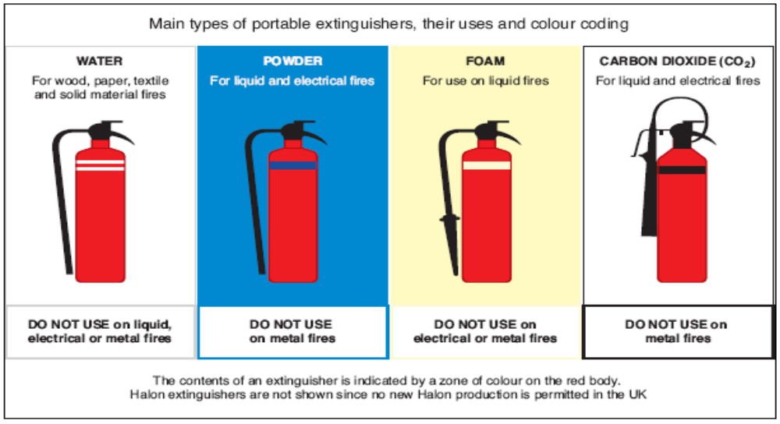

Monthly Check
This is a simple visual check to ensure that all the extinguishers are in their proper positions and have not been discharged, lost pressure (those fitted with pressure indicators) or suffered any obvious damage. Make a note of the quantity, type and location of extinguishers that your premises contain and record in the log book. A good practice is to also identify each extinguisher with a number as this will assist you in the ongoing management and maintenance of them.
As a general rule fire extinguishers should be sited on exit routes, preferably near exit doors or where they are provided for specific risks, near to the hazards they protect. It is now also a requirement that the location of all firefighting equipment is identified by notices which contain a graphic symbol. See Health & Safety (Signs and Signals) Regulations 1996.

Annual Inspection
The annual inspection should be carried out by the contract service engineer or a suitably trained member of staff using the appropriate tools and manufacturers recommended procedures.

Intervals of discharge
The recommended times, in each case since the date of manufacture or the last actual discharge (test or otherwise) of the particular extinguisher body are as follows:

- Water, Powder, Foam and Water based Foam, Every five years extended service and recharge if necessary.
- Powder-Primary sealed. Every ten years extended service and recharge if necessary.
- CO2. Overhauled and recharged every ten years.

Fire Blankets
Inspect and check to manufacturers instructions.
Fire Fighting Equipment - Record of Tests

Date | Result of Inspection/Test  Satisfactory/Faulty | Remedial Action Taken | Fault Rectified (Date) | Signature

8. Sprinkler Systems

General

Automatic sprinklers may be conditional to the insurance policy of premises and as such should be maintained in accordance with the terms and conditions of the insurance policy to ensure full and adequate protection.

In addition, a sprinkler system may form part of an engineered solution or compensation for departure from normally accepted fire safety standards or building regulations. As such, the sprinkler system must be maintained to ensure those departures are consistent with the Fire Safety Risk assessment. Where a sprinkler system forms part of an engineered solution it may also be subject to an Alterations Notice, under article 29 of the RR (FS) O, and the maintenance requirements of article 17 of the RR (FS) O

The installer of the Automatic Fire Sprinkler System should provide to the occupier an inspection and programme of checks for the system. The programme should include; instruction on the action to be taken in respect of faults, operation of the system, in particular the procedure for emergency manual starting of any pumps and details of daily and weekly routines.

Weekly

The following checks shall be made and recorded;

- All water and air pressure gauge readings on installations, trunk mains and pressure tanks
- All water levels in elevated private reservoirs, rivers, lakes and water storage tanks.

Water Motor Alarm Test

Each water motor alarm shall be sounded for not less than 30 seconds

Automatic Pump Starting Test

Test on automatic pumps shall include;

- Check fuel and engine lubricating levels
- Reduce water pressure on starting device to simulate condition of auto-start
- Record the starting (cut-in) pressure and check it is correct.

Quarterly / Six Monthly / Annual Routines

The service and maintenance schedules detailed in the current British Standard should be carried by a competent person who will supply the user with a signed and dated report of the inspection.

Record of Tests of Sprinkler System

Normal Gauge Pressure Range | Water Gauge |  | Air Pressure |  | Pump Cut-In Pressure | Diesel Engine Restart | Batteries | Stop Valves  Zone Valves | Signature
Normal Gauge Pressure Range | Satisfactory  Yes/No |  | Satisfactory  Yes/No
Date

9. Smoke Ventilation Systems

Smoke ventilations systems may be provided as part of an engineered solution and as such may be subject to an Alterations Notice, under article 29 of the RR (FS) O and the maintenance requirements of Article 17 of the RR (FS) O. Furthermore, if the smoke ventilation system is provided for the assistance of fire-fighting purposes, it will also be subject to Article 38 of the RR (FS) O.

The ventilation system test should be carried out in accordance with the manufacturer’s instructions, in order to meet the requirements of the current British or European equivalent, standards.

Weekly

During the Fire Alarm test, check that all smoke ventilators and smoke curtains have operated correctly and they are properly re-set at the conclusion of the test.

Annually

The system should be tested by a specialist engineer in accordance with the current British or European equivalent, standards.

Record of Tests of Smoke Ventilation System

Date of Tests | Curtains / Ventilators |  | Compressor |  | Annual Service / Test | Signature
Date of Tests | Satisfactory | Unsatisfactory | Receiver Pressure | Hours Run Meter | Annual Service / Test | Signature

10. Miscellaneous Provisions

General

There are many features that may be provided within premises that relate to Fire Safety, or provided to assist the Fire and Rescue Service in dealing with an incident safely and more effectively to minimise the impact of a fire in a building. These facilities may be provided for one or more of the following reasons;

- Condition of insurance
- Part of an engineered solution
- Requirement at time of building, or major refurbishment
- Compensation for departures from normal building regulations
- Deemed necessary as part of the Fire Safety Risk Assessment.

As such, the facilities provided may be subject to one, or more, of the articles of the Regulatory Reform (Fire Safety) Order and, if provided, should be maintained to the relevant industry standard, which will usually be the British Standard, or European equivalent.

Facilities provided may include one or more of the following;

- Foam inlets
- Wet / Dry Risers
- Drencher systems
- Inert gas Flooding systems
- Pressurised stairways and corridors
- Fire fighting shafts, with dedicated lifts

The following check list is intended to provide only a guide and you should seek advice from your individual service provider on the necessary maintenance regime to ensure full compliance with the law and insurance conditions.

The Fire Service or local authority building control may be able to assist if the premises have only recently been constructed or undergone building works that were subject to local authority approval.

For further information regarding engineered solutions please contact our Business Fire Safety Engineering Department.

Tel: 01443 232500

E-Mail:
firesafety@southwales-fire.gov.uk

Visit our Website:
www.southwales-fire.gov.uk

Record of Tests of Miscellaneous Provisions

Date of Test | Item / Feature Tested | Frequency  of Test  e.g. weekly, monthly | Pass / Fail  General Remarks | Signature

11. Fire Instruction and Training

It is important that all staff should receive basic fire training in what to do in the event of fire, including those who work irregular hours, part time or casually employed.

Article 21.1 Regulatory Reform (Fire Safety) Order 2005

The responsible person must ensure that his employees are provided with adequate safety training.

The training should focus on the following general areas:-

Actions to be taken in the event of fire - how to raise the alarm.

Evacuation Procedures - identifying the location and use of escape routes, fire alarm call points, firefighting equipment and nominated assembly points.

How to call the Fire Brigade - premises procedures.

In addition to the above, certain members of staff in large buildings may also be nominated to carry out specific tasks in the event of fire and these should also be incorporated to ensure procedures are carried out efficiently and safely.

All staff should receive information and training on the fire safety provisions within the premises as soon as possible after being appointed and at regular intervals thereafter, (at least annually). The information given should be based on your emergency action plan and must include:

- The significant findings of your fire risk assessment
- Staff fire procedures.
- The identity of persons with responsibilities for fire safety: - fire wardens etc.
- The measures that are in place to reduce/mitigate the effects of fire.
- Any special arrangements that are in place
- The location of emergency exits and fire-fighting equipment (and the use of if appropriate).

For further information please contact our Business Fire Safety Department.

Tel: 01443 232500

E-Mail:
firesafety@southwales-fire.gov.uk

Visit our Website:
www.southwales-fire.gov.uk
Record of Staff Training / Instruction

Date | Instruction Duration | Person Receiving Instruction | Signature of Person | Nature of Instruction | Signature  of Instructor
12. Fire Drill / Evacuation

Drills should be conducted to simulate fire conditions and to test fire procedures and all staff should be conversant with the premises evacuation procedures and take part in fire evacuation drills at least once and preferably twice per year.

Article 15.1 Regulatory Reform (Fire Safety) Order 2005

The responsible person must establish and, where necessary, give effect to appropriate procedures, including safety drills, to be followed in the event of serious and imminent danger to relevant persons.

Fire Drills and practice evacuations should not be used to embarrass staff, or unduly inconvenience people. However, they are crucial in testing local procedures for evacuating the premises and highlighting problem areas which may need addressing.

Ideally, most people should be aware that a fire drill is due to take place, in order to minimise any adverse effects and provide staff with time to ensure they are familiar with alternative exit routes. It may not always be possible to alert everyone, especially if the premises have relatively open access or are used by the public.

Debriefs on the effectiveness of the drills should be carried out so that any evacuation procedures can be changed if necessary.

Date And Time | Person Responsible for Drill | Number Of Staff Involved | Time Taken To Evacuate | Optimum Time To Evacuate
Simulation (i.e. Normal Route blocked/fire in foyer)

Assessment
of Drill

Recommendations or further actions required.

Record of Fire Drills / Evacuations

Date | Nature of Drill | Persons/Sections Taking Part | Evacuation Time | Person in Charge | Signature

13. Fire Safety Risk Assessment

It is necessary for the responsible person to ensure that a suitable and sufficient risk assessment of the risk of fire is carried out.

Article 9.1 Regulatory Reform (Fire Safety) Order 2005

The responsible person must make a suitable and sufficient assessment of the risks to which relevant persons are exposed for the purposes of identifying the general fire precautions he needs to take

The risk assessment and the significant findings should recorded in the following circumstances;

- If there are 5, or more, employees.

- The premises are licensed.

- An Alterations Notice is in force.

The following table can be used as a record of when a Fire Safety Risk assessment is carried out and when the next risk assessment is due.

Record of Carrying out of Fire Safety Risk Assessment

Date Risk Assessment Carried Out | Name of Person Conducting Risk Assessment | Brief Comments | Date Next Due

Further information and guidance is available in Part 1 of the series of fire safety guides published by the Department for Communities and Local Government and available to download from www.communities.gov.uk/ or to purchase from your nearest TSO outlet.
14. Business Continuity and Planning

Fires in industrial and commercial premises can have a serious impact on both national and local economy. There is a risk of significant job losses with subsequent social and economic impact on the community as well as environmental damage.

When considering incidents at premises for the purpose of business continuity it should be borne in mind that approximately 60% of all companies involved in a serious fire are unable to re-start after the fire. Many businesses that experience a serious fire do not recover. Significant parts of the building or premises may have been affected and could remain unusable for some time.

By taking a short moment to consider the impact that a fire might have on your business, you may be able to minimize the impact and ensure survival of your business in the longer term, as well as the survival of people and property in the short term.

The following is intended as prompt rather than a full record of contacts and record of documentations.

List of Considerations and Actions for Business Continuity Following Disruption

Consideration | Satisfactory  Yes / No | Further Action Required
Salvage plan prepared and held in secure location away from main premises
Contract agreements in place and up to date for fire / flood restoration
Computer files backed up daily to separate server / location away from main building
Temporary accommodation ear-marked and available
Alternate service provider(s) listed to maintain customer continuity
Insurance policy checked for cover against loss of revenue and relocation
List of emergency contacts up to date and available
Other Considerations
Other Considerations
Other Considerations
Other Considerations

